Unit 8: Moles and Solutions Name:___________________________
Learning Targets
- I CAN report my answer to a calculation in the correct number of significant digits *review
- I CAN write a given value in scientific notation *review
- I CAN define the mole and describe it’s use in chemistry
- I CAN solve a problem using dimensional analysis (multi-step conversions) *review
- I CAN calculate the molar mass (formula weight) of a compound
- I CAN describe a hydrate and calculate its molar mass
- I CAN convert in between mass, moles, and atoms/molecules.
- I CAN calculate the percent composition of an element in a compound
- I CAN use data collected in lab to determine the empirical formula for a compound
- I CAN use data collected in lab to determine the molecular formula for a compound
- I CAN describe the components of a solution (solute, solvent)
- I CAN describe the solubility of a compound in water using a saturation curve (unsaturated, saturated, or supersaturated)
- I CAN calculate the concentration of a solution (moles and mass of solute, volume of solvent, molarity)
- I CAN calculate the amount of water needed to dilute a solution

Chemistry Important Dates!
Monday | Tuesday | Wednesday | Thursday | Friday | Saturday | Sunday
March 27 | 28 | 29 | 30 | 31 | 1 | 2
3 | 4 | 5 | 6 | 7 | 8 | 9
10 | 11 | 12 | 13 | 14 | 15 | 16
No… Not this kind of mole!
Notes on What is a Mole?
Inquiry into “The Mole”
Purpose/Objective
Understand the relationship between the mass of an
element and the number of particles (the mole).
The Model
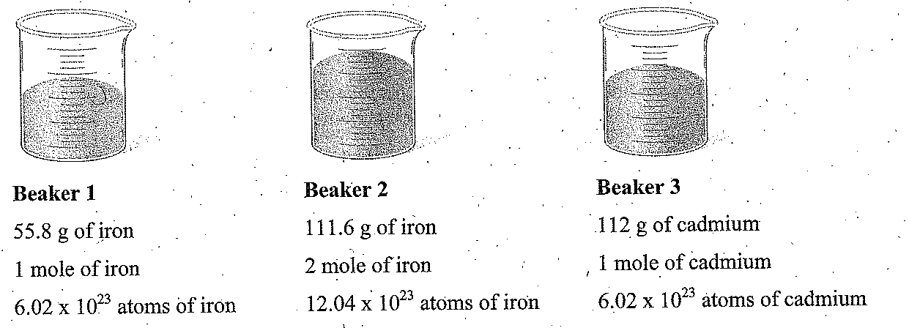

Use “The Model” on the previous page to answer the following questions:

- Which beaker (1 or 2) has more atoms of iron? ____________
- How many grams of iron are in
Beaker 1? __________
Beaker 2? __________
- How many moles of iron are in:
Beaker 1? __________
Beaker 2? __________
- How many atoms of iron are in
Beaker 1? __________
Beaker 2? __________
Exploring the Model
- Write an equality statement between grams of iron and moles of iron in Beaker 1.
Write an equality statement between grams of iron and moles of iron in Beaker 2.

Is there a relationship between the equality for Beaker 1 and Beaker 2?

- Write the equality between grams of cadmium and moles of cadmium.

- Write the equalities above (problems 5 and 6) as conversion factors.
Iron: Cadmium:

- Compare this information for each element above to the information on the periodic table. Is there a relationship between the information given and your answers to number 7?
Evaluate Your Understanding
- If you are given a mole of atoms of each of the following, what would the mass (grams) be?
- Carbon

- Potassium

- Chlorine

- So, how many particles (atoms/molecules/bicycles, etc) in one mole? ___________________

Exercising Your Knowledge
- Different elements, their masses and numbers of particles and moles are listed below. Complete the table with the missing information for each element. DO NOT USE A CALCULATOR.
Element | Mass of Sample | Number of Particles in Sample | Number of Moles in Sample
Magnesium |  | 6.02 x 10²³ atoms | 1.00 moles
Arsenic | 150. grams
 | 23.0 grams | 6.02 x 10²³ atoms
Lithium | 13.9 grams
 | 34.3 grams |  | 0.25 moles
Boron |  | 3.01 x 10²³ atoms
Silicon | 56.2 grams
 | 40.4 grams | 1.204 x 10²⁴ atoms
Iodine |  |  | 0.25 moles
 | 100. grams |  | 0.50 moles
- If you have two different samples, the first with an actual mass of 100.0 g of silver and the second with an actual mass of 100.0 g of gold, which sample has more atoms (or are they the same)? Explain your answer.
Hint: Set up conversion factors for each substance.

- You have half a mole of M & M’s, how many M & M’s do you have?
- If you have 3.01 x 10²³ apples, how many moles of apples do you have?
Summarizing Your Thoughts
- Based on what you thought in question 12, explain why it is difficult to compare chemical quantities using only the mass of samples.

- Consider the number of hydrogen atoms needed for a mass of 1 gram. How would that compare to the amount of jelly beans you needed to have a mass of 1 gram?

- What do you think might be the benefit of working in terms of moles when using chemicals?

- Complete the following:
  - For any element, one mole is equal to its _______________________ which can be found on the periodic table.
  - One mole = _________________ particles
Notes on Molar Mass
Molar Mass (Formula Weight) Calculations
Directions: Determine the Molar Mass (the mass of one mole) of each of the compounds below.
Formula Molar Mass
- KMnO₄
- KCl
- Na₂SO₄
- Ca(NO₃)₂
- Al₂(SO₄)₃
- (NH₄)₃PO₄
- H₂CO₃
- Mg₃(PO₄)₂
- Fe₂(SO₃)₃

Notes on Hydrates

Hydrates Molar Mass Practice

- Zn₃(PO₄)₂·4H₂O
- Zn(CH₃COO)₂·2H₂O
- Hg₂Cr₂O₇
- Ba(ClO₃)₂
- CuSO₄·5H₂O
- NH₄C₂H₃O₂

What is a Hydrate?

Draw a representation of CuSO₄·5H₂O

Notes on Mole Road Conversions
Mole Road: One-Step Conversions
Directions: Set up all problems using dimensional analysis (conversion factors). NO WORK = NO CREDIT!

1. How many moles is each of the following?
a. 4.81 X 10²⁴ atoms of Li

b. 2.408 x 10²⁴ atoms of aluminum

c. 4.816 x 10²² atoms of hydrogen

d. 6.02 x 10²² molecules Br₂

e. 1.5 x 10²³ molecules NH₃

2. How many atoms are in each of the following?
a. 4.2 moles of manganese

b. 7.5 moles of iodine

3. How many moles is each of the following?
a. 13.95 grams of phosphorous

b. 24 grams of Br₂

c. 68.95 g of gold

d. 160 g of copper

e. 25.6 g of sulfur

4. What is the mass (in grams) of:
a. 1.2 mol of iron?

b. 2.5 moles of platinum

c. 0.3 moles of bromine

d. 2.408 x 10²³ atoms of oxygen?

Mole Road: One-Step and Two-Step Conversions
Directions: Set up all problems using dimensional analysis (conversion factors). NO WORK = NO CREDIT!

- Find the number of atoms in:
  - 402 grams of mercury
  - 204 grams of magnesium
- Determine the number of moles in each of the quantities below
  - 25g NaCl
  - 125g of H₂SO₄
  - 100.g of KMnO₄
  - 74g of KCl
  - 35g of CuSO₄·5H₂O

- Determine the number of grams in each of the quantities below.

- 3.2 x 10²³ formula units CuSO₄·5H₂O

- 2.81 x 10²⁴ molecules of H₂SO₄

- 1.70 x 10²² formula units of KMnO₄

- 3.85 x 10²³ formula units of KCl
- 1.461 x 10²³ atoms of Mn

Mole Practice!
Directions: Set up all problems using dimensional analysis (conversion factors). NO WORK = NO CREDIT!
1. Calculate the formula weights or Molar Masses of the following:
a. H₃PO₄
b. K₂C₄H₄O₆
c. (NH₄)₃PO₄
d. CuSO₄ · 5H₂O

2. How many moles are contained in: SHOW ALL OF YOUR WORK!
  - 15.56g Al₂O₃

b. 4.40 x 10⁻²g CO₂

- 95.4g C₂H₆

- 2.45 g H₂SO₄

- 8.00 g H₂O₂

- 2.45 g H₃PO₄

- 1.25 g Fe₂O₃

- 47.5 g F₂

3. How many grams are contained in: SHOW ALL OF YOUR WORK!

a. 0.258 moles Al₂O₃

b. 4.40 x 10⁻² moles SO₂

c. 95.4 moles C₃H₈

d. 0.245 moles H₂SO₄

e. 0.800 moles CaSO₄

f. 2.45 moles H₂CO₃

g . 1.25 moles Co₂O₃

i. 50 moles H₃PO₄

j. 29 moles K₂C₄H₄O₆

k. 56 moles (NH₄)₃PO₄

EVEN Mole Practice!
Directions: Set up all problems using dimensional analysis (conversion factors). NO WORK = NO CREDIT!
- What is the molar mass of:

  - H₂
  - Mg(OH)₂
  - CO₂
  - NH₄Cl
  - CuSO₄
  - AgNO₃

- Convert each of the following:
- How many moles is 12.5 g of magnesium hydroxide?

- How many moles is 1.46 g of hydrogen gas (H₂)?

- How many grams are in 4.3 moles of ammonium chloride?

- How many molecules are in 2.0 moles of hydrogen gas (H₂)?

- How many moles is 2.0 x 10²⁵ molecules of silver nitrate?
- How many atoms of oxygen are in 2.4 x 10²³ molecules of copper(II) sulfate?

  - How many molecules are in 96 g of carbon dioxide?

  - How many oxygen atoms are in 96 g of CO₂?

  - How many grams would 1.0 x 10²⁵ molecules of copper (II) sulfate weigh?

  - How much does each individual molecule of copper (II) sulfate weigh?

Notes on Empirical and Molecular Formulas
Empirical and Molecular Formula Practice: SHOW ALL OF YOUR WORK!

    - Find the empirical formula of the following compound from its percent composition.

52.8% Sn, 12.4% Fe, 16.0% C and 18.8% N

Formula: ____________________
    - Determine the molecular formula of the following compound.

54.5% C, 13.6% H and 31.8% N; Molar Mass = 88g

Formula: ____________________

    - How are the empirical and molecular formulas of a compound related?

The Strange Case of Mole Airlines Flight 1023
Scene of the Crash
At 6:02 a.m. you and your team of medical examiners are called to the scene of a plane crash. You find evidence of a pre-crash explosion. At the site of the explosion a material has been found. Subsequent chemical analysis of the material shows it was:

C 37.01% H 2.22% N 18.5% O 42.27%

The mangled passengers are found in and around the crash. They must be identified by the substances found in their belongings or in their bodies, since they are not recognizable and their dental records are not available. Upon further investigation one passenger was suspected of having been murdered before the crash - the time of death was approximated at one hour prior to the crash.

Your Job:
1) Use the percent composition data in Table 3 to determine formulas for the compounds found with or in the passengers. Do the work on a separate paper and record the empirical formula in the column to the right on table 3. Make sure to show all of your work as it is your work that will be graded. Match these formulas with the identity of each compound listed in Table 1. Be certain to use the number of significant figures in the analysis to determine the number of significant figures you need to use from the periodic table. For example: If four significant figures are given in the data, use four significant figures from the periodic table.
2) Use the personal data in Table 2 to make a probable identification of each passenger.
- Record the identifications on the Victim Identification Form.
- Include the evidence that supports your identification. The solution to the mystery is the one that the evidence points to by logical deduction.
- Determine who was murdered.
- Determine who is most likely to have committed the murder.
- Determine the identity of the substance that was found at the site of the explosion.

Table 1: Possible Compounds Table 2: Personal Data
Identity Formula Notes  Codeine C₁₈H₂₁NO₃ Pain killer, prescription controlled  Cocaine C₁₇H₂₁NO₄ Narcotic, illegal  Aspirin C₉H₈O₄ Pain killer  Aspartame C₁₄H₁₈N₂O₅ Artificial sweetener  Vanilla C₈H₈O₃ Flavoring  Trinitrotoluene C₇H₅N₃O₆ Explosive (TNT-dynamite)  Nitroglycerine C₃H₅N₃O₉ Explosive, heart medication  Curare C₄₀H₄₄N₄O Poison  Thiobromine C₇H₈N₄O₂ Chocolate (flavoring)  Strychnine C₂₁H₂₂N₂O₂ Rat poison  Dimetacrine C₁₀H₁₃N* Prescription drug, antidepressant  Acetaminophen C₈H₉NO₂ Pain killer (Tylenol) | Passengers & Crew Notes  Redd D. Tocroak Has a heart condition  Polly Pillcounter Pharmacist  Hoagie Bunn Baker  Archie Givengrades Teacher, addicted to sugar free drinks  Threwit Allaway Professional athlete, just suspended for drug violations  Ivy Isa Nissue Environmental engineer, severely depressed  Iselle Ubye Suspected drug dealer  Norm Anderson Suspected leader of a terrorist organization

*the empirical formula rather than the actual formula is
used.

Table 3: Percent Composition Data of the Compounds Found in or with the Passengers’ Bodies
Passenger | Compound Analysis (%) |  |  |  | Location | Empirical Formula and Substance ID
 | C | H | N | O
1 | 67.31 | 6.98 | 4.62 | 21.10 | Blood
2 | 63.15 | 5.30 | -- | 31.55 | Face
2 | 46.66 | 4.48 | 31.1 | 17.76 | Stomach
3 | 72.15 | 7.08 | 4.68 | 16.03 | Pockets (2000 tablets
4 | 15.87 | 2.22 | 18.15 | 63.41 | Blood and Pockets
5 | 75.42 | 6.63 | 8.38 | 9.57 | Blood
5 | 37.01 | 2.22 | 18.5 | 42.27 | Pockets
6 | 57.14 | 6.16 | 9.52 | 27.18 | Pockets
7 | 81.19 | 7.51 | 9.39 | 2.68 | Pockets
7 | 81.58 | 8.90 | 9.52 | -- | Pockets
8 | 60.00 | 4.48 | -- | 35.53 | Pocket
8 | 63.56 | 6.00 | 9.27 | 21.17 | Pocket

Victim Identification Form

Passenger | Most Probable Identity | Evidence that Supports Identification
1
2
3
4
5
6
7
8
____________________________was murdered by _________________________

Identity of Substance at the site of the explosion: ____________________________

Certified by _____________________________ Date __________________

Solubility Graph Practice
Notes on Parts of Solutions and Solubility
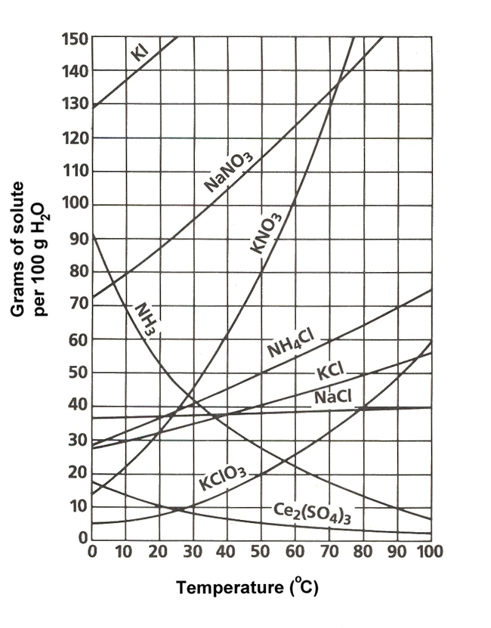
- What are the two axis of the graph?

- The curve represents what?
- Any amount of solute below the line indicates what type of solution?

- Any amount of solute above the line represents what type of solution?

- Solutes whose curves move upward are indicating that solubility___________ as temperature ___________.

- Solutes whose curves move downward indicate that solubility__________ as temperature ____________.

Solubility Problems to solve
- At 10ºC, how many grams ofNaNO₃ will dissolve in 100 mL of water?

- What temperature would be required to completely dissolve 100 grams of Sodium Nitrate?

- If 30 grams of Sodium Chloride dissolved in 100 grams of water at 30 degrees, what type of solution would it be?
Solubility Practice

- Which of the salts shown on the graph is the least soluble in water at 10ºC?

- Which of the salts has the greatest solubility at 10ºC?

- Which of the salts has its solubility affected the least by a change in temperature?

- How many grams of sodium nitrate must be added to 100 ml to saturate the solution at 50ºC?

- At what temperature do saturated solutions of potassium nitrate and sodium nitrate contain the same weight of solute per 100 mL of water?

- What two salts have the same degree
of solubility at approximately 19ºC?

- A saturated solution of potassium nitrate is prepared at 60ºC using 100.mL of water. How many grams of solute will precipitate out of solution if the temperature is suddenly cooled to 30ºC?

- How many more grams of Potassium Nitrate will dissolve when the temperature of water increases from e temperature range of 60ºC to 70ºC?

- If 50. mL of water that is saturated with KClO₃ at 25ºC is slowly evaporated to dryness, how many grams of the dry salt would be recovered?

- Thirty grams of KCl are dissolved in 100 mL of water at 45ºC. How many additional grams of KCl are needed to make the solution saturated at 80ºC?

- Are the following solutions saturated, unsaturated or supersaturated (assume that all three could form supersaturated solutions)
- 40. g of KCl in 100 mL of water at 80ºC
- 120. g of KNO₃ in 100 mL of water at 60ºC
- 80. g of NaNO₃ in 100 mL of water at 10ºC

12. Based on the curve of NH₃, we can assume that it is a __________________. (solid or gas)

Notes on Concentration (% by Mass and Molarity)

Concentration Practice
Determine the molarity of the following solutions. SHOW ALL OF YOUR WORK.

- Determine the percent composition by mass of a 100 g salt solution that contains 20 g of salt.
- Calculate the mass of solvent in grams in a solution containing 3.0 grams of Tylenol if the mass percent is 3.5%.
- 0.50 moles of sodium chloride is dissolved to make 0.75 liters of solution.
- 0.50 grams of sodium chloride is dissolved to make 0.075 liters of solution.
Molarity Practice
- 0.50 grams of sodium chloride is dissolved to make 0.075 mL of solution.
- 734 grams of lithium sulfate are dissolved to make 875 mL of solution.
- 6.7 x 10⁻² grams of Pb(C₂H₃O₂)₄ are dissolved to make 3.5 mL of solution.
- I have two solutions. In the first solution, 1.0 moles of sodium chloride is dissolved to make 1.0 liters of solution. In the second one, 1.0 moles of sodium chloride is added to 1.0 liters of water. Is the molarity of each solution the same? Explain your answer.
- How many grams of potassium carbonate are needed to make 200 mL of a 2.5 M solution?
- How many liters of 4 M solution can be made using 100 grams of lithium bromide?
- What is the concentration of a 450 mL solution that contains 200 grams of iron (II) chloride?
- How many grams of ammonium sulfate are needed to make a 0.25 M solution with 2.5 L
- What is the concentration of a solution that has a volume of 2.5 L and contains 660 grams of calcium phosphate?
- How many grams of copper (II) fluoride are needed to make 6.7 liters of a 1.2 M solution?
- How many liters of 0.88 M solution can be made with 25.5 grams of lithium fluoride?
- What is the concentration of a solution that with a volume of 660 ml that contains 33.4 grams of aluminum acetate?
Dilutions Practice
Notes on Dilutions

- If I add 25 mL of water to 125 mL of a 0.15 M NaOH solution, what will the molarity of the diluted solution be?

- If I add water to 100.0 mL of a 0.15 M NaOH solution until the final volume is 150 mL, what will the molarity of the diluted solution be?

- How much 0.05 M HCl solution can be made by diluting 250 mL of 10 M HCl?

- I have 345 mL of a 1.5 M NaCl solution. If I boil the water until the volume of the solution is 250 mL, what will the molarity of the solution be?
Unit 8 Review: Moles and Solutions

Find the molar mass of:
1. CH₄ 2. Ca(NO₃)₂ 3. iron(II) oxide

4. How many moles are in 75.1g of FeO?

5. How many grams are in 2.5 moles of CH₄?

6. a. How many molecules of Ca(NO₃)₂ in 10.9 moles?

b. How many oxygen atoms are there?

7. How many grams of FeO are in 1.96 x 10²⁴ molecules?

8. How many molecules are in 72.6g of CH₄?

9.What is the molarity of a 50.0mL solution that contains 29.04g NaCl?

10. Narcotics agents confiscated an unknown substance that was suspected to be methaqualone. Its molecular formula is C₁₆H₁₄N₂O. Analysis found the sample to have 77% carbon, 5.5% hydrogen, 15.3% nitrogen, and the rest oxygen. Was it methaqualone?

11. What mass of CO₂ has the same number of molecules as 192g of H₂O?

12. A gas containing carbon and oxygen is decomposed and is found to contain 0.36g of carbon and 0.48g of oxygen. What is the empirical formula of this gas?

14. The empirical formula of a compound is CH₂O₂. The actual molar mass of this compound is 184g. What is the molecular formula of the compound?

15. A 31.0g sample of rust (an iron oxide) is composed of 21.7g of iron. Determine the empirical formula of this rust and give the correct chemical name.

16. Caffeine contains 49.98% C, 5.15% H, 28.87% N, and 16.49% O, and has a molar mass of 194.2 g/mol. What is its molecular formula?

Answer Key: 1. 16.0 g/mol 2. 164.1 g/mol 3. 71.8 g/mol 4. 1.05 moles 5. 40.g 6a. 6.56 x 10²⁴ molecules
6b. 3.94 x 10²⁵ atoms O 7. 234g 8. 2.73 x 10²⁴ 9. 9.94M 10. No 11. 469g 12. CO
13. 17.5g Mg(OH)₂ 14. C₄H₈O₈ 15. empirical = Fe₂O₃ name = iron(III) oxide 16. C₈H₁₀N₄O₂

