Final Exam Study Guide (CP and Honors) Name: __________________________
Measurements in Science:
- Determine the correct number of significant digits:

  - 356.56 = _________
  - 0.00201 = _________
  - 23000 = __________
  - 34.000 = _________

- Record your answer in the correct number of significant digits:

  - 3.5 + 2.003 = __________
  - 2.35 x 1200 = __________
  - 100.50 – 22.445 = ________
  - 80.626 / 21 = ____________

Atomic Structure:
- List the three subatomic particles, their location, their charge, and their relative size compared to each other:
Particle | Location | Charge | Relative Size (amu)

- Name the group each element is a part of, write the number of valence electrons and determine the oxidation number.
- Nitrogen B) Calcium C) Chlorine D) Neon E) Iron
Fill in the blanks with the correct terms:
- ______________ is equal the number of protons in an atom.
- ______________ is the average mass of all the isotopes for a particular element.
- ______________ is the sum of the protons and neutrons of an atom.
- ______________ are forms of the same element, but different numbers of neutrons.
- ______________ are atoms that have gained or lost electrons.
- ______________ Vertical columns on the periodic table. All elements in these columns have similar properties.
- ______________ Horizontal rows on the periodic table. All elements in these rows have same # of energy levels.
- ______________ Term for the number of electrons gained lost or shared in order to get an octet.
- ______________ are the outermost electrons for an atom.
- ______________ type of bonding where electrons are transferred. Formed between a metal and nonmetal
- ______________ type of bonding where electrons are shared. Formed between two nonmetals.
- ______________ The equation for this is (Experimental / Actual) x 100
- ______________ are to the left of the staircase and have ________ oxidation numbers. These atoms lose e⁻.
- ______________ are to the right of the staircase and have _______ oxidation numbers. These atoms gain e⁻.
- ______________ are the elements that touch the staircase. They have properties of both metals and nonmetals.
- ______________ the sum of the oxidation numbers in an ionic bond.

- Fill in the following table:
NAME | SYMBOL | ATOMIC # | MASS # | PROTONS | ELECTRONS | NEUTRONS | CHARGE
 | $${}_{28}^{59}{Ni}$$ |  | 59 |  |  |  | 0
 |  | 38 | 88 |  | 36
 |  |  | 33 | 15 |  |  | -3

Periodic Trends and Light:
- Explain the difference between electronegativity and electron affinity. In what directions on the periodic table do they both increase?

- Define ionization energy. In what directions on the periodic table does it increase?

- Identify the element that has the highest: A) electronegativity, B) atomic radius, and C) ionization energy.

- When an atom becomes a cation, what happens to its # of electrons and its overall radius? When at atom becomes an anion, what happens to its # of electrons and its overall radius?

- Describe the complete process in which an atom of sodium would give off light, as they do in many streetlights.

- HONORS: Using the equations c = λν and E = hν if a ray of light has a wavelength of 7.00 x 10⁻⁷ m, what is the frequency of this wave? What is the energy of this wave, where h is planck’s constant and = 6.626 x 10⁻³⁴?

- Each element gives off a unique set of spectral lines which show the individual colors of light given off by the atom. Sketch what a set of spectral lines would look like from an absorption spectrum and an emission spectrum. Label which parts would be colored and which would be black.

Electron Configuration and Orbital Diagrams:
- Write the full electron configuration for the following elements: Mg, Fe, and Br

- Write the noble gas electron configuration (using the noble gas as a shortcut) for the elements In, Ta, and Ti

- Draw the noble gas orbital diagrams (boxes and arrows using the noble gas as a shortcut) for: S, As, and Zr

- Describe Hund’s rule, Pauli’s Exclusion Principle, and the Aufbau Principle for orbital diagrams, and show an example for each where it is not being correctly followed.

- Using the example of Arsenic (As) above, how many valence electrons does it have? Which orbitals are included in this number?

- An orbital is one region where a pair of electrons are most likely to be found. These orbitals are grouped into sublevels based on their shape and the order they are filled. How many orbitals are in each of the 4 different sublevels (s,p,d,f)?

Nuclear Chemistry
- What does it mean for an atom to be radioactive? What is it going to do eventually as a result of this?

- Give the nuclear symbol with the numbers of an alpha particle, a beta particle, and a gamma ray. Describe how powerful each one is based on how deep it can penetrate.

- Describe the difference between nuclear fusion and nuclear fission, including the starting substances, products, and temperatures at which they occur. Give 2 examples where process occurs.

- An example of a half-life chart is shown. Mathematically, what is happening to the mass as you move down the column? What is happening to the time column?
Mass | Time | # of Half-lives
100 g | 0 s | 0
50 g | 75 s | 1
25 g | 150 s | 2
12.5 g | 225 s | 3
6.25 g | 300 s | 4

- How much of an 800 kg sample of carbon-14 is leftover after 28650 years, if C-14 has a half-life of 5730 years?

Naming and Bonding:
- Name the following compounds: Determine if they are Ionic and if a Trans. Metal is present, Covalent or an Acid.
A) CaBr₂ = ___________________ B) NiP = _____________________ C) N₃O₇= ______________________
D) AlF₃ = ____________________ E) H₂S = ____________________ F) CuBr₂ = ____________________
G) KNO₃= _____________________ H) CCl₄ = ____________________ I) S₂F₃= ______________________
J) H₂SO₄= ____________________ K) ZnI₃ = _____________________ L) H₂PO₃= ______________________
M) B₂Br₅ = ____________________ N) Mn(ClO₄)₂ = ________________ O) HCl = ____________________
- Write the correct formulas for the following compounds:
A) Lithium Sulfite = ____________ B) Iron (II) Phosphide= __________ C) Tetrasulfur Pentafluoride = ________
D) Phosphoric Acid = ____________ E) Barium Nitride= ____________ F) Hydronitric Acid = _______________
G) Copper (III) Iodide = __________ H) Aluminum Phosphate= _________ I) Calcium Oxide= _________________
J) Barium Oxide = _____________ K) Gallium Hydroxide = ____________ L) Silicon Heptabromide = ___________
M) Ammonium Phosphate = _____________________ N) Sulfurous Acid = ____________________________

Molecular Geometry and Intermolecular Forces
- An attraction between two molecules due to a small difference in electronegativity is _____________________
- When there is an unequal sharing of electrons within a molecule, it is said to be __________________________
- When a molecule has perfect symmetry and all bonding regions are the same, it is considered _______________
- HONORS: A special type of dipole-dipole interaction that involves OH, FH and NH bonds____________________
- HONORS: An intermolecular force achieved when electrons temporary shift is called ______________________
- Draw the Lewis Dot for each molecule. Determine if the Bonds are polar or nonpolar, and if the Molecule is polar or nonpolar. HONORS: Write what type of intermolecular bonding each of these examples will have and why?

A) CF₄ B) HCl C) S

D) PBr₃ E) BrI F) SiF₄

- Determine which molecule of the pair has the greater bond polarity, explain why.
A) Carbon Disulfide or Sulfur Difluoride
B) Boron Trihydride or Ammonia (NH₃)

Chemical Reactions:
For the following, balance and classify the reactions:
- ____ C₃H₈ + ____ O₂ _____ CO₂ + _____H₂O Rxn type:________________
- ____ HBr + ____Ca(OH)₂ ____H₂O + _____CaBr₂ Rxn type:________________
- ____ Pb + ____ H₃PO₄ ____ H₂ + ____ Pb₃(PO₄)₂ Rxn type:________________
- ____ AlBr₃ + ____ K₂SO₄ ____ KBr + ____ Al₂(SO₄)₃ Rxn type:________________
- ____ Hg₂I₂ + _____ O₂ _____ Hg₂O + _____ I₂ Rxn type:________________
- ____ N₂O₅ _____ O₂ + ______NO₂ Rxn type:________________
Translate, predict the products, and then balance the equation. Include states of matter!
- Potassium reacts with Aluminum Sulfate

- Silver Nitride combines with Magnesium Sulfite

- Phosphoric Acid reacts with Barium Hydroxide

For the reactions below, identify the oxidizing agent, the reducing agent, what has been reduced, and what has been oxidized.
- 4Na + O₂ 2Na₂O

- Mg(NO₃)₂ + 2Li 2LiNO₃ + Mg

HONORS: For the following two reactions, determine the Net Ionic Reactions:
- Mg(ClO₃)₂ + 2NH₄OH Mg(OH)₂ + 2NH₄ClO₃

- 2LiF + BeSO4 Li₂SO₄ + BeF₂

Molar Conversions
- For the following, determine the molar mass of each compound:
A) MgCl₂ B) Mg(OH)₂ C) Ca(NO₃)₂

- Determine the percent composition by mass of sodium for the following two compounds.
NaBr: Na₂S:

- Determine the number of moles in 2.5 grams of O₂

- Determine the number of grams in 2.5 moles of O₂

- Determine the number of particles in 2.5 moles of O₂

- Determine the number of grams in 2.5 x 10²³ formula units of NaCl

- Determine the moles of 200 grams of CaO

- Determine the number of atoms in 36 grams of Carbon.

- A compound, Ammonium Bromate has the following percent composition by mass. Determine the empirical formula for the compound.
9.59 % Nitrogen 2.76 % Hydrogen 54.74 % Bromine 32.89 % Oxygen

- You have determined that an empirical formula of a compound is CH₂O. What would be the molecular formula for glucose if its molecular mass is 180 grams/mol?

- An empirical formula for an Alkane would be C₂H₆. What would be the molecular formula for Decane, with a molecular mass of 150.4 g/mol?
Solutions and Dilutions
- What is the percent by mass of a NaCl if 5.68 grams of the salt is dissolved in 150 mL of water?
- How many grams of KClO₄ is dissolved into a 175 grams of solution that is 3.5 % by mass?
- How many grams of AlCl₃ are required to make a 2.25M solution in 30.0 mL of water?

- What volume of 12M HCl is needed to prepare 250 mL of 0.20M HCl?

- A solution contains 8.3 moles of NaCl in 1250 mL of water. What is its molarity?
- If 150 mL of water is added to 250 mL of a 3.1 M solution, what is the molarity of the new solution?
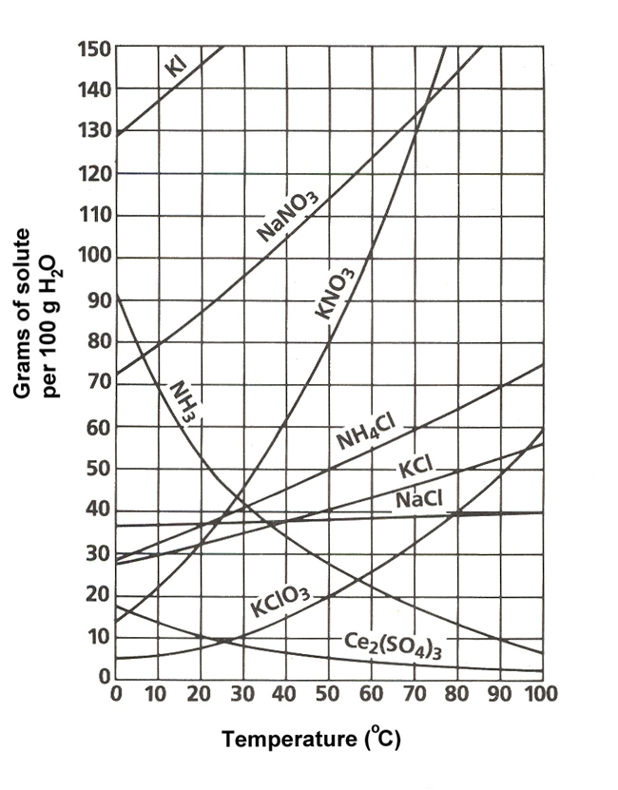
- How much water is added to 500. mL of 6.8 M solution to dilute it to a molarity of 3.2 M?
Use the solubility graph to the right to answer the following questions:

- What is the least soluble compound at 20 ⁰ C?
- According the slop of the line for NH₃, we can assume that it is a ________.
- 60 grams of KNO₃ are dissolved at 50⁰ C. How many grams of KNO₃ would need the be added to saturate the solution at this temperature?
- What two salts have the same degree of solubility at 19⁰ C?
- A saturated solution of potassium nitrate is prepared at 60⁰ C using 100. mL of water. How many grams of solute will precipitate out of the solution if the temperature is suddenly cooled to 30⁰ C?
- If 50. mL of water that is saturated with KClO₃ at 25⁰ C is solely evaporated to dryness, how many grams of the dry salt would be recovered?
- Which of the salts has the greatest solubility at 10⁰ C?

Stoichiometry
- If you have 12 grams of Nitrogen, how many moles of Ammonia (NH₃) will you have?
____N₂ + ____ H₂ ____NH₃

- If you have 3.5 moles of Hydrogen, how many grams of Ammonia(NH₃) will you produce?

- 4.5 moles of Calcium are used, how many moles of Lithium will be produced?
___Ca + ____ LiF ____CaF₂ + ____Li

- 45.8 grams of Lithium Fluoride will produce how many grams of Calcium Fluoride?

- If an experiment yields 3.56 grams of product, and the mass expected from calculations is 4.2 grams, what is your percent yield?
- What is a limiting reactant?

- HONORS: If 5.6 grams of hydrochloric acid is reacted with 10.4 grams of calcium hydroxide, how many grams of water will be produced? What is the limiting reactant?

Acids & Bases
State whether the following are acids or bases, or both.

- Have a sour taste.
- Has a pOH of 8.5
- Feel slippery
- Has a pH of 8.5.
- Damaging to skin if concentrated
- Turns blue litmus paper red
- Produces hydronium ions according to Arrhenius
- Produces hydroxide ions according to Arrhenius
- Donates protons according to Bronsted-Lowry
- Accepts protons according to Bronsted-Lowry
- Can produce hydrogen gas if reacting with metals
- Found in Milk of Magnesia

- HONORS: A solution has an H+ concentration of 1.27 x 10⁻¹² M. What is the pOH of the solution? Is it an acid or base?

- HONORS: A solution has a pOH of 3.46. What is the pH of the solution?

Gas Laws
- What are the five principles of kinetic molecular theory?

- Some students believe that teachers are full of hot air. If Ms. K inhales 2.2 liters of gas at a temperature of 18⁰ C and it heats to a temperature of 38⁰ C in her lungs, what is the new volume of the gas?

- What is the Ideal Gas Law? What units do you have to use when using the Ideal Gas Law?

- A gas has a volume of 400.0 mL at 3.00 °C and 120.0 torr. What would the volume of the gas be at 117.0 °C and 3350.0 torr of pressure?

- If there is a gas at 440.0 mmHg with a volume of 350.0 mL, what volume does this change to when the pressure is changed to 1.5 atm?

- If a gas is closed in a container at 23.0 ⁰C then pressurized from 855 torr to 1422 torr, what will the new temperature of the gas be?

- How much pressure would 0.389 moles of Neon gas exert on a 275 mL container at 32ºC?

Thermochemistry
Heating Curve for Solution X

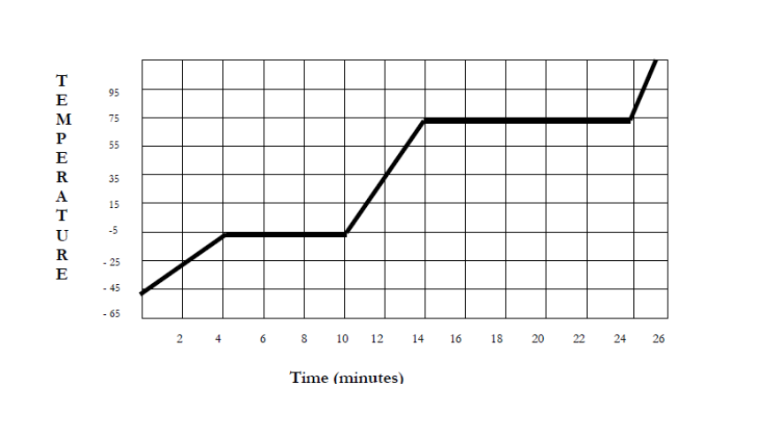
Use the heating curve to the right to answer the following questions:

- During what times would solid be found in the beaker?
- During what times would liquid be found in the beaker?
- During what times would gas be found in the beaker?

Indicate whether a heating curve would be flat or rising.
- liquid is boiling  - solid is warming  - solid is melting | - kinetic energy (temp) is increasing  - Only gas exists

Describe the following processes as endothermic or exothermic, and describe if heat is absorbed or released:

- Freezing
- Condensing
- Melting
- Vaporizing
- Depositing
- Subliming

HONORS: Refer to the phase diagram below when answering the questions
NOTE: “Normal” refers to STP – Standard Temperature and Pressure.
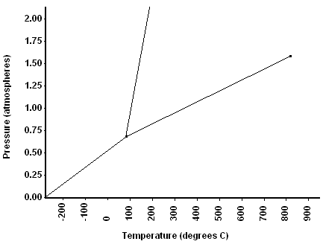

- What are the values for temperature and pressure at STP? T= ________, P= _______
- What is the normal freezing point of this substance? _______
- What is the normal boiling point of this substance? _______
- What is the phase (s, l, g) of a substance at 0.5 atm and 100 °C? _______
- What is the phase (s, l, g) of a substance at 1.5 atm and 200 °C? _________
- If this substance was at a pressure of 2.0 atm, at what temperature would it melt? ___________
- If this substance was at a pressure of 2.0 atm, at what temperature would it boil? ___________
Use your Heat of Formations Chart to calculate the change in enthalpy for the following reactions:
- ___CH₄(g) + ___O₂(g) ---> ___CO₂(g) + ___H₂O(l)
- ___H₂S(g) + ___ O₂(g) ---> ___H₂O(l) + ___SO₂(g)
- ___NO(g) + ___O₂(g) ---> ___NO₂(g)
- ___ SO₂(g) + ___O₂(g) ---> ___SO₃(g)

