Common Assessment 3 Study Guide (Honors) Name_______________________________

1. Aqueous solutions of silver nitrate and potassium chloride are mixed.
Chemical Equation
Net Ionic
2. Aqueous solutions of magnesium nitrate and sodium carbonate are mixed.
Chemical Equation
Net Ionic

3. What two things are required to create a solution?
4. Describe the differences between dissolve, dissociate, ionize, and precipitate. Provide examples of substances that would undergo each type of chemical process.
5. Not all solutions are solids dissolved in liquids. Give two examples of different types of solutions that do not involve solids dissolving in water.
6. What are the differences in saturated, unsaturated, and supersaturated solutions?
7. How could you tell by looking at a solution if it was saturated or not?

8. 0.450 moles of NaCl are dissolved in 95.0 mL of water. Calculate the molarity of the NaCl solution.

9. 45.0 g of Calcium Nitrate was used to create a 1.30 M solution. What is the volume of the solution?

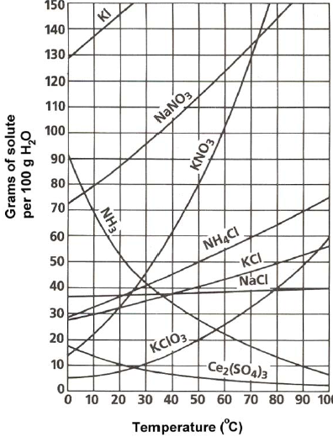
10) How many grams of sodium nitrate can be dissolved in 100 ml of water at 20 ºC?

11) 50.0 grams of ammonium chloride dissolved in 100 ml of water at 50 ºC, would create what type of solution? (saturated, unsaturated, supersaturated)

12) The solubility of NH₃ is decreasing over time. That suggests that NH₃ is?

13) How many grams of KI could dissolve in 50 ml of water at 20 ºC?
14) What is the least soluble at 20 ºC?

15) 3.65 grams of sodium chloride is dissolved in 50.0 mL of water. Determine the percent by mass of sodium chloride.
16) 3.75 moles of potassium nitrate is dissolved in 1.5 L of water. Determine the percent by mass of potassium nitrate.

17) Balance the reaction: _____Na₂SO₄ + _____BaCl₂ ____BaSO₄ + _____ NaCl
A) If 45.0 grams of barium chloride is used, how many moles of barium sulfate would be created?
B) How many grams of sodium sulfate are required to create 450 ml of a 2.0 M solution?

C) How many liters of solution will be needed to create a 2.45 M solution containing 60.0 grams of barium
chloride?
D) If 5.3 grams of Barium Chloride and 6.4 grams of sodium sulfate are reacted, what is the theoretical yield of
Barium Sulfate?
If a student carried out this experiment a produced 4.4 grams of Barium Sulfate, what would be the percent
yield?

18) _____H₂SO₄ + _____Al(OH)₃ _____Al₂(SO₄)₃ + _____H₂O
A) In order to create 750.0 mL of 1.75 M sulfuric acid, how many grams would be required?
B) What is the theoretical yield of water when of 35.0 mL 2.50 M sulfuric acid reacts with 45.0 mL of 1.75 M
aluminum hydroxide solution? (Limiting Reactant!)

19) Determine the percent composition of nitrogen in NO₂.
20) If a sample of ethyl butyrate is known to contain 0.620 g of carbon, 0.103 g of hydrogen and 0.276 g of oxygen, what is the empirical formula for ethyl butyrate?
21) A compound with an empirical formula of C₄H₄O and a molar mass of 136 grams per mole. What is the molecular formula of this compound?

22) Determine the molecular formula of a compound that is 7.79 % Carbon and 92.21% Chlorine. The actual compound has a molar mass of 88 grams per mole.

23) When do we use the units of atoms? Molecules? Formula Units?

24) Convert 2.55 grams of aluminum hydroxide to formula units.
25) 4.5 x 10²³ atoms of zinc would be equal to how many moles?
26) 2.5 moles of sodium phosphide would have what mass?

27) Write the balanced equation for the reaction between sulfuric acid and aluminum hydroxide.

- If you have 4.6 mol of sulfuric acid and 4.6 mol of aluminum hydroxide, how many grams of water would form?
- If I only had 175.0 mL of aluminum hydroxide solution, what molarity of that solution would be required to produce exactly 85.0 grams/mL of water?
- 45.0 mL of water is added to 1.20 L of an 8.0 M sulfuric acid solution. Determine the molarity of the new solution.
28) An example of dissociation is when an _______________ compound is added to water and breaks
apart into ______________.

29) The limiting reactant determines when a reaction will _______________ and how much
___________________ can theoretically be produced.

