Unit 4: Periodic Table Trends Name: ________________________ Block: _____
Learning Targets
- Review: I CAN identify groups/families on the periodic table
- Review: I CAN identify the metals, non-metals, and metalloids
- Review: I CAN define valence electron and determine the number of valence electrons in a given element
- Review: I CAN determine the oxidation number (charge) for a main group element using the periodic table.
- I CAN describe the concept of nuclear pull; if given two elements I CAN decide which has a greater nuclear pull
- I CAN describe and draw trend lines for electronegativity, ionization energy, and atomic/ionic radius
- I CAN compare two elements using the trends of electronegativity, ionization energy, atomic radius, and ion radius.
- I CAN justify the trends of the periodic table (nuclear pull, electronegativity, ionization energy, atomic radius, ionic radius) by explaining how an atom’s structure influences its behavior

Chemistry Important Dates!
Monday | Tuesday | Wednesday | Thursday | Friday | Saturday | Sunday
February 13 | 14 | 15 | 16 | 17 | 18 | 19
20 | 21 | 22 | 23 | 24 | 25 | 26
27 | 28 | March 1 | 2 | 3 | 4 | 5

Periodic Trends Web Quest
Purpose: In this activity, we will look at 3 properties and trends on the Periodic Table: Use the Internet to help define the following terms. Write sentences that you actually understand, and don’t just copy words.

Atomic radius:

Electronegativity:
Ionization Energy:
Use the website www.chemicool.com and find the information for these elements. To access the data, you will need to click the element and then the “Data Zone” and then click the “Show More” near the bottom of the section.
 | Lithium - Li | Carbon - C | Oxygen - O
Atomic Radii
Electronegativity
1st Ionization Energy
 | Sodium - Na | Silicon - Si | Sulfur - S
Atomic Radii
Electronegativity
1st Ionization Energy
1. What appears to be the trend in atomic radius as you move from left to right across a period on the periodic table?

2. What appears to be the trend electronegativity and 1st ionization energy as you move from left to right across a period?

3. What appears to be the trend in atomic radius as you move from top to bottom, down a group on the periodic table?

4. What appears to be the trend electronegativity and 1st ionization energy as you move from top to bottom, down a group?

5. Based on these trends and the data in your table; predict the Atomic Radii, Electronegativity, and 1st Ionization Energy for the element Boron. Then go back and verify using the www.chemicool.com website:

6. Explain your predicted numbers. How did you know what number to select? (It should be based on the trend)

 | Predicted Boron - B | Actual Boron - B
Atomic Radii
Electronegativity
1st Ionization Energy

7. Based on these trends and the data in your table; predict the Atomic Radii, Electronegativity, and 1st Ionization Energy for the element Potassium. Then go back and verify using the www.chemicool.com website:
 | Predicted Potassium - K | Actual Potassium - K
Atomic Radii
Electronegativity
1st Ionization Energy

8. Explain your predicted number. How did you know what number to select? (It should be based on the trend)

Conclusion: Summarize your findings in this Web Quest in a few complete sentences. Discuss the three trends and their patterns/trends across groups and periods. Use the periodic table to the right to draw arrows showing the direction that each trend INCREASES.

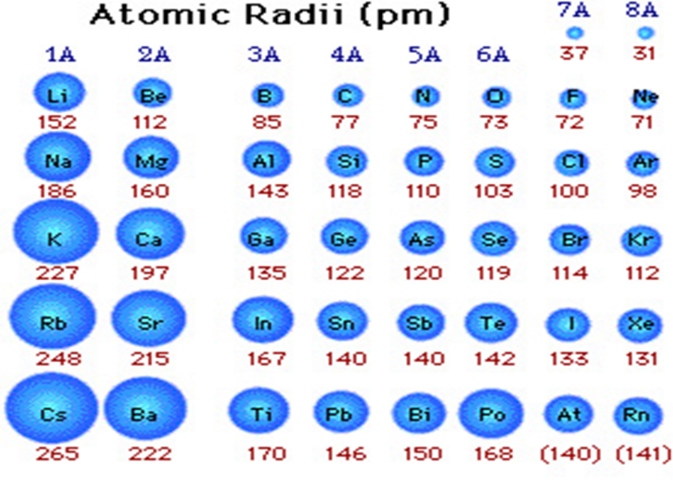
Notes on Atomic Radius
Notes on Nuclear Pull
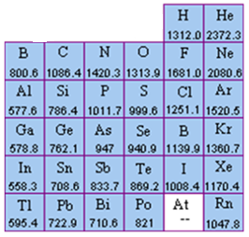
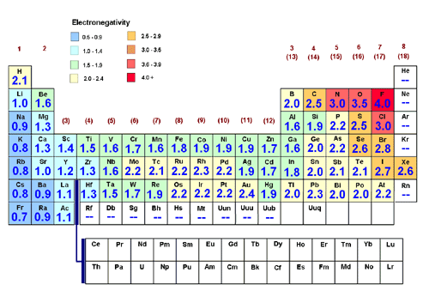
Notes on Ionization Energy
Notes on Electronegativity
Periodic Trends Review
Increase Atomic Radii Electronegativity Larger
Increase Transition Metals Nonmetals Smaller
Decrease Metalloids Metals
Decrease Nuclear Pull Noble Gases

- The attraction from the nucleus to another atom’s electrons is called _______________________.

- As you move down a group, electronegativity will __________________________.

- Moving across a period, the number of protons increases and causes ______________________ to increase.

- Electronegativity tends to _______________________ across periods on the table.

- The distance from the nucleus to the outer most electrons is known as __________________________.

- Some ______________________ do not have measured electronegativity since they do not form compounds.

- When ______________________ form ions, the ions are smaller than the original atoms.

- Moving from left to right, the atomic radii of atoms _____________________________.

- The elements that are on the staircase are called ___________________________________.

- The ions of nonmetal atoms will be _______________________ than the neutral atoms.

- In each grouping, choose the element with the greatest first ionization energy:
  - Carbon or Aluminum

  - Calcium or Strontium

  - Helium or Lithium

- Which has the higher ionization energy, sodium or potassium? Explain why:

- Arrange the following elements in order from lowest to highest electronegativity:
  - gallium, aluminum, indium
  - calcium, selenium, arsenic

- Circle the atom in each pairing with the larger atomic radius?
  - Li or K
  - Ca or Ni
  - Ga or B
  - Cl or Br

- Which of the following is larger and WHY: a potassium atom, a potassium ion with a charge of 1+?

- Which of the following is larger and WHY: a chlorine atom, a chlorine ion with a charge of 1- ?
- The amount of energy levels increases as you move down a ________ on the periodic table.

- Period
- Group
- Both
- Neither

- In any ______, the number of electrons between the nucleus and the outer energy level is the same.

  - Period
  - Group
  - Both
  - Neither

- Which of these elements would have the greatest electronegativity?

  - Na
  - Al
  - P
  - Ar

- Which of these elements would have the highest shielding effect?

- Na
- Li
- Rb
- H

- Between the elements Calcium, Barium, and Magnesium, choose the element that has the:
- lowest ionization energy
- greatest electronegativity
- largest atomic radius
- Between the elements, Gallium, Selenium, and Potassium, choose the element that has the:
- lowest ionization energy
- smallest atomic radii
- lowest electronegativity

- When an atom loses electrons, the atomic (ionic) radii becomes ____________________________

- When an atom gains extra electrons, the atomic (ionic) radii becomes __________________________

- As you move across a period, the number of ___________________ is increasing, and causes what?

- As you move down a group, the number of ____________________ is increasing, and causes what?

Periodic Trends Extra Practice
Answer the questions for each sections by comparing the elements in each section:
1) B Al Ga
a) Which will have the lowest electronegativity?
b) Highest ionization energy?
c) Largest atomic radius?
d) Which are metals?
e) List them from largest to smallest in atomic radii.
f) Which would gain electrons to become stable?
g) Would the ions of these elements be larger or smaller than the neutral atoms?

2) Sb Sn I
a) Which would have the most metallic properties?
b) Highest electron affinity?
c) Lowest Ionization energy?
d) Smallest atomic radii?
e) Which are metalloids?
f) When Iodine becomes an ion, is the ion larger or smaller than the atom?
g) Which one is a halogen?

3) Ca Ba Mg
a) Lowest electronegativity?
b) Highest ionization energy?
c) Which are non-metals?
d) List them in order from the highest to the lowest electronegativity.
e) Would the ion be larger or smaller than the atoms?
f) Lowest electron affinity?

4) Si Al P
a) Highest electron affinity?
b) Lowest ionization energy?
c) Smallest atomic radii?
d) Which are metalloids?
e) List in order of increasing size (from small to large)
f) Which are non-metals?
g) Lowest electronegativity?

5) In each set, tell which is larger
a) Ca v. K
b) As v. P
c) O v. O ⁻²
d) Ca v. Ca⁺²
e) O⁻² v. F⁻¹

6) Arrange the following in increasing (smallest to largest) atomic radii
a) sulfur, chlorine, aluminum, and sodium.
b) carbon, germanium, lead, silicon

7) Arrange the following in increasing Ionization Energy
a) Be, Mg, Sr
b) Bi, Cs, Ba

8) In each of the following pairs, which element is the most electronegative?
a) chlorine, fluorine
b) carbon, nitrogen
c) magnesium, neon
d) arsenic, calcium

