Unit 3: Electrons and Light Name: _____________________ Block: _______

|  |
| --- |
| **Learning Targets** |
| 1. I CAN describe the characteristics of metals, non-metals, and metalloids and their location on the periodic table |
| 1. I CAN describe the difference between families and groups on the periodic table; I CAN name the families on the periodic table describe the commonalities between the elements in a group |
| 1. I CAN draw a Bohr Model for an atom |
| 1. I CAN define valence electrons and use the periodic table to determine how many valence electrons an atom has |
| 1. I CAN describe an ion and calculate the number of protons, neutrons, and electrons in an ion. |
| 1. I CAN assign oxidation numbers for monoatomic ions using the periodic table |
| 1. I CAN describe the electromagnetic spectrum and compare the wavelengths of waves on the spectrum |
| 1. I CAN explain the relationships between energy, wavelength, and frequency |
| 1. I CAN describe how light is produced; I CAN explain how different colored light is produced |
| 1. I CAN describe the energy levels (1, 2, 3, 4, etc...), sublevels (s, p, d, f), and orbitals. |
| 1. I CAN write the electron configuration for any given atom; I CAN identify the atom when given its electron configuration |
| 1. I CAN write and interpret an orbital diagram; I CAN identify the atom when given its orbital diagram |

|  |  |  |  |  |  |  |
| --- | --- | --- | --- | --- | --- | --- |
| Chemistry Important Dates! | | | | | | |
| Monday | Tuesday | Wednesday | Thursday | Friday | Saturday | Sunday |
| February 6 | 7 | 8 | 9 | 10  Pep Assembly | 11 | 12 |
| 13 | 14 | 15  Early Dismissal | 16 | 17 | 18 | 19 |
| 20  NO SCHOOL | 21 | 22 | 23  45 min ADV | 24 | 25 | 26 |

**Notes on Ions DRAW the examples of Sodium and Oxygen!**

# Practice with Ions

|  |  |  |  |  |
| --- | --- | --- | --- | --- |
| **Element Name** | **Ion Symbol** | **Number of Protons** | **Number of Electrons** | **Number of Electrons Lost or Gained** |
| Fluorine | $$F^{-1}$$ | 9 | 10 | Gained one |
|  |  | 53 | 54 |  |
|  |  | 16 |  | Gained two |
| Potassium |  |  |  | Lost one |
|  | $${Ca}^{+2}$$ |  |  |  |
|  |  | 35 | 36 |  |
|  | $$H^{+1}$$ |  |  |  |

# Practice with Atoms, Isotopes, and Ions

|  |  |  |  |  |  |  |  |
| --- | --- | --- | --- | --- | --- | --- | --- |
| **Isotope Name** | **Isotope Symbol** | **Atomic Number** | **Mass Number** | **Charge**  **(C = P- E)** | **# of Protons** | **# of Electrons** | **# of Neutrons** |
| Calcium-40 | $${}_{20}^{40}{{Ca}^{+2}}$$ | 20 | 40 | +2 | 20 | 18 | 20 |
|  |  | 12 | 24 | +1 |  |  |  |
|  |  |  |  |  | 1 | 1 | 2 |
|  | $${}_{79}^{179}{Au}$$ |  |  |  |  |  |  |
|  |  | 28 |  |  |  | 26 | 30 |
|  |  |  | 201 | +2 | 80 |  |  |
|  |  | 17 |  | 0 |  |  | 18 |
|  | $${}_{16}^{33}{S^{-2}}$$ |  |  |  |  |  |  |
|  |  | 92 |  |  |  | 92 | 149 |
|  |  |  | 76 | -3 |  |  | 43 |
|  |  | 29 |  | +2 |  |  | 35 |
|  |  |  | 127 | -1 | 53 |  |  |
|  |  | 55 |  |  |  | 55 | 78 |
| Nitrogen-15 |  |  |  | -3 |  |  |  |
|  | $${}_{47}^{111}{{Ag}^{+1}}$$ |  |  |  |  |  |  |

Use your periodic table and your knowledge of atoms, isotopes, and ions to complete the following chart:

**Directions**: The illustration below represents the first three rows of elements on the periodic table (Excluding the Transition metals). In the blanks, write the names of the groups and inside each box finish the Bohr diagrams by drawing the correct number of electrons on the appropriate energy levels.

**Note**: The first energy level can hold only two electrons, the second eight, and the third will hold eight. (FYI the third energy level can hold more.)

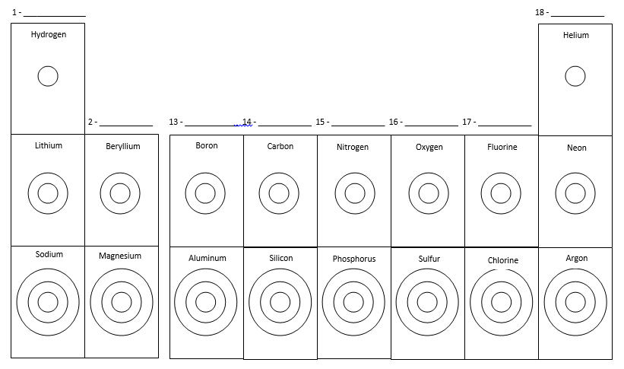 What are the horizontal rows called? What do they have in common?

What are the vertical columns called? What do they have in common?

# Practice with Oxidation Numbers

Determine the oxidation number for the following elements by filling in all the information:

|  |  |  |  |  |  |
| --- | --- | --- | --- | --- | --- |
| **Element Name** | **Group #** | **# of Valence Electrons** | **Should electrons be added or lost?** | **How many electrons should be transferred to become stable?** | **What is the oxidation number?** |
| Calcium |  |  |  |  |  |
| Fluorine |  |  |  |  |  |
| Aluminum |  |  |  |  |  |
| Neon |  |  |  |  |  |
| Lithium |  |  |  |  |  |
| Phosphorous |  |  |  |  |  |

Write the number of valence electrons **and** the oxidation number for the following elements:

Bromine Strontium Gallium Sodium

Selenium Barium Hydrogen Helium

Indium Iodine Germanium Nitrogen

Fluorine Aluminum Calcium Lithium

**Practice with EM Spectrum and Waves**

**Notes on Electromagnetic Spectrum and Waves DRAW and LABEL a wave!**

1. Draw a wave and label the amplitude, wavelength, crest, trough, and frequency.
2. Light can exist as both a ______________ or in particle form, called a ______________.
3. List the types of waves on the electromagnetic spectrum from longest wavelength to shortest.
4. List the colors of the visible light spectrum from highest to lowest frequency.
5. Explain the relationship between frequency and wavelength (as wavelength increases, what happens to frequency?). Use the equations c=λf and E=hf to explain your reasoning.
6. In each case, circle the wave that has the higher frequency:  
   A) Microwave or Infrared B) Ultraviolet or Radio C) X-rays or Infrared
7. In each case, circle the wave that has the longer wavelength:   
   A) Infrared or Ultraviolet B) Green or Yellow C) X-ray or Gamma

**Notes on How Light is Emitted from an Atom**

**Notes on the Electron Configuration and Orbital Diagrams**

**Notes on the Quantum Mechanical Model of the Atom**

**Atomic Orbitals Web Quest**

**Instructions:**

* **Go to this website:** [**http://www.learner.org/interactives/periodic/index.html**](http://www.learner.org/interactives/periodic/index.html)
* **Using this website, gain some extra practice with how electrons are configured. Apply this knoeldge to the periodic table. Start by selecting “It’s Elementary” tab at the top and answer the questions as you go.**

1. What is the Aufbau Principle?
2. List the three different energy levels discussed, including how many orbitals they have and the maximum number of electrons.

|  |  |  |  |
| --- | --- | --- | --- |
| 3 Energy Levels |  |  |  |
| Number of Orbitals |  |  |  |
| Maximum # of Electrons |  |  |  |

1. Which energy level is filled first?
2. Draw the following orbitals:   
   s orbital px orbital py orbital pz orbital
3. What is Hund’s Rule?

1. 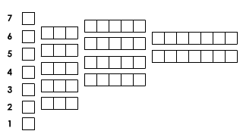Write out the electron configuration and the orbital notation for the following elements:   
   Sulfur Magnesium

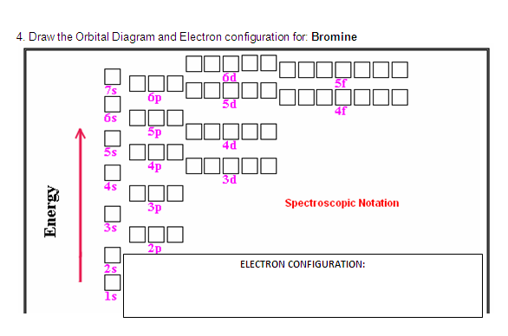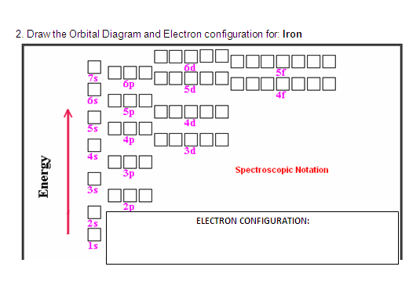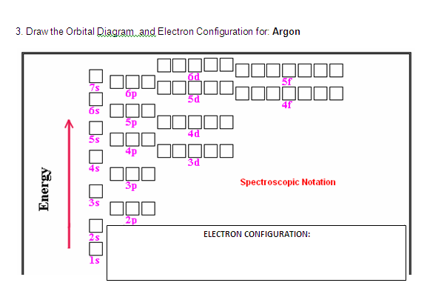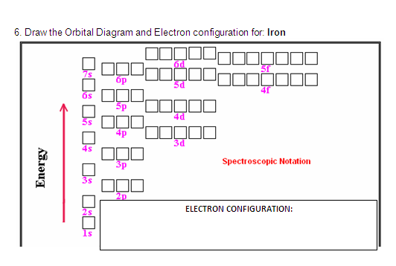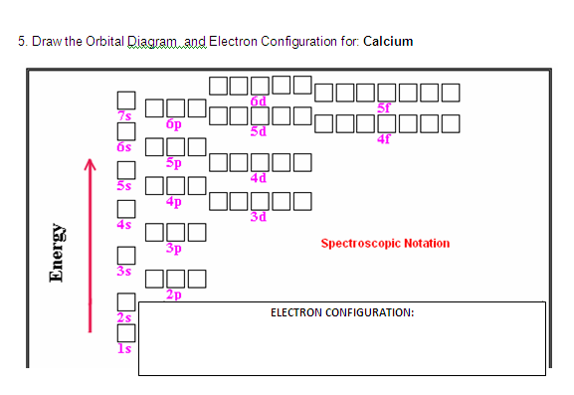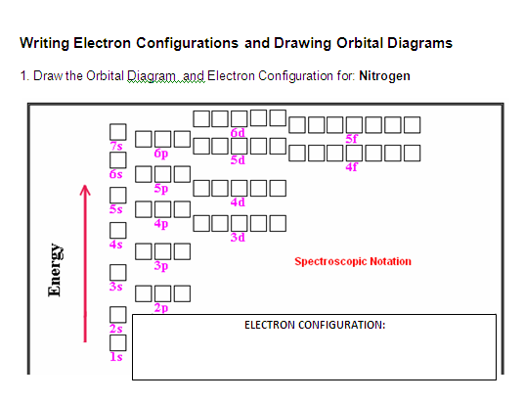

**Practice Writing Orbital Diagrams and Electron Configurations**

**Copper**

**Practice Writing Electron Configurations and Orbital Diagrams**

For each given element, fill in the orbital diagram with correct arrows.

|  |  |  |  |  |  |  |
| --- | --- | --- | --- | --- | --- | --- |
|  |  |  | |  |  |  |
| Element: Ar  # of e–’s: ___ | Element: Mg  # of e–’s: ___ | Element: N  # of e–’s: ___ | | Element: Li  # of e–’s: ___ | Element: P  # of e–’s: ___ | Element: Cl  # of e–’s: ___ |
|  | | | | Fill in the orbital diagram for the element Germanium, and write the electron configuration of Ge:  Ge: | | | | |
|  | | | | Fill in the orbital diagram for the element, Cr, and write the electron configuration Chromium.  Cr: | | | | |
|  | | | | Fill in the orbital diagram for the element, Zn, and write the electron configuration of Zinc.  Zn: | | | | |

1) Fill in the orbital diagram for the element Beryllium:

Complete Electron Configuration:

Noble Gas Configuration (Shorthand):

2) Fill in the orbital diagram for the element Nickel:

Complete Electron Configuration:

Noble Gas Configuration (Shorthand):

3) Fill in the orbital diagram for the element Phosphorus:

Complete Electron Configuration:

Noble Gas Configuration (Shorthand):

**Unit 3 Review: Electrons and Light**

1. Complete the following chart using your Periodic Table and your knowledge of atomic structure

|  |  |  |  |  |  |  |  |
| --- | --- | --- | --- | --- | --- | --- | --- |
| **Isotope Name** | **Isotopic Symbol** | **Atomic Number** | **Mass Number** | **Charge** | **# of Protons** | **# of Electrons** | **# of Neutrons** |
| Carbon-14 |  |  |  | 0 |  |  |  |
|  |  | 12 | 24 |  |  | 10 |  |
|  | $${}_{5}^{12}B$$ |  |  | +3 |  |  |  |
|  |  | 16 |  |  |  | 18 | 18 |
| Chlorine-35 |  |  |  |  | 17 | 18 |  |
|  | $${}_{13}^{27}{{Al}^{+3}}$$ |  |  |  |  |  |  |
| Nitrogen-15 |  |  |  | -3 |  |  |  |
|  |  |  | 16 | -3 |  | 10 |  |
|  |  |  |  | +2 |  | 2 | 5 |

1. Write a short summary statement explaining the relationship between the following terms: orbitals, energy levels, electron cloud and sublevels.
2. Fill in the missing parts of the chart:

|  |  |  |
| --- | --- | --- |
| **Sublevel** | # of Orbitals | Total # of Electrons |
| f |  |  |
|  | 3 |  |
| s |  |  |
|  |  | 10 |

1. Write the electron configuration for the **last** electron in each of the following elements.

(Some have been done for you).

H Be B N *2p3* F Ne

Li Mg Al P Cl Ar

Na *3s1* Ca Ga As Br Kr

K Sr In Sb I Xe

Rb Ba Tl Bi At Rn *6p6*

Cs Ra

1. The ions S2-, Cl-, K+, and Ca2+ have the same electron configuration. This means that they are ***isoelectronic***.   
   What neutral element shares that same electron configuration?
2. Write the **electron configuration** for the element in the previous question. (1s22s22p6…etc)
3. What neutral atoms have the following electron configurations?

a. 1s22s22p63s23p3 c. 1s22s22p63s23p64s23d4

b. 1s22s1 d. 1s22s22p63s23p64s23d104p5

1. What do the electron configurations of all the noble gases except helium have in common?
2. Why is helium stable, even though it has a different electron configuration than the other noble gases?
3. Write the **electron configurations** for the following **ions**.

a. Rb+  c. S2-b. Be2+ d. Br-

1. Write the electron configurations for the following compounds:
   1. Calcium:
   2. Rubidium:
   3. Lead: