Unit 12: Thermochemistry & Equilibrium Name: _________________
Learning Target
- I CAN state and describe the four states of matter based on energy, arrangement of particles, movement, shape and volume
- I CAN state and describe the phase changes between the states of matter and describe whether they are endo- or exo-thermic
- I CAN apply the states of matter and phase changes to a heating and cooling curve
- I CAN identify and describe the difference between an endothermic and exothermic reactions, and provide a real life example
- I CAN identify and describe an endothermic or exothermic reaction based on a potential energy diagram
- I CAN calculate the enthalpy of a reaction from a potential energy diagram
- I CAN state the five factors that affect rates of reactions and describe how the rates are affected using kinetic theory
- I CAN describe a catalyst and how it affects activation energy
- I CAN describe Le Châtlier’s Principle.
- I CAN state how the stresses of temperature, pressure, and change in concentration affect a reaction
Chemistry Important Dates!
Monday | Tuesday | Wednesday | Thursday | Friday | Saturday | Sunday
May 15 | 16 | 17 | 18 | 19 | 20 | 21
22 | 23 | 24 | 25 | 26 | 27 | 28
29 | 30 | 31 | June 1 | 2 | 3 | 4

Phase Changes/States of Matter:
Notes on Heating and Cooling Curves Draw BOTH curves and include all phase changes that occur.

- Solid Liquid _________________________

- Liquid Solid _________________________

- Liquid Gas _________________________

- Gas Liquid _________________________

- Solid Gas __________________________

- Gas Solid __________________________

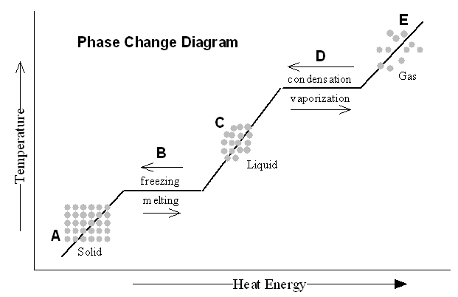
Heating and Cooling Curves
Heating and Cooling Curve
- When changing from solid to liquid, the substance isn’t entirely___________ until the graph has a ____________ slope
- At point A the substance is ___________________
- At point B the substance is ___________________
- At point C the substance is ___________________
- At point D the substance is ___________________
- At point E the substance is ___________________
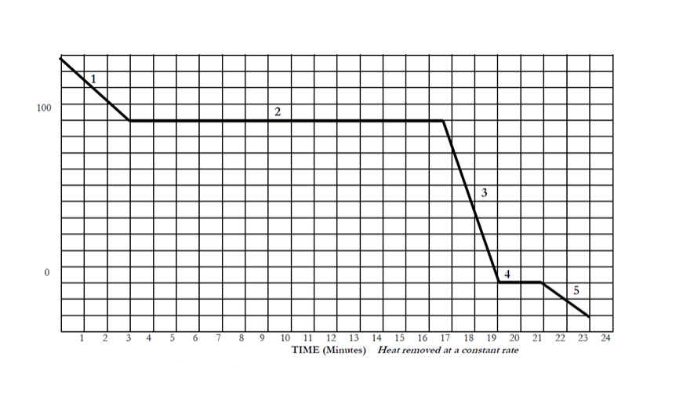
Cooling Curve for Water
Identify the sections where the following phases are found:
1) ____ Only a gas 2) ____ Only a solid 3) ____ Only a liquid
Identify which letter would be appropriate for each question: More than one letter may be required
4) _______ Freezing (if cooling) 5) _______ Particles are the farthest apart

6) _______ Liquid phase is present 7) _______ All areas where only one phase is present

8) _______ Evaporation 9) _______ All areas where multiple phases are present

10) Moving from letter B to C, energy will be _____ 11) Moving from point D to C, energy will be ____

12) At what time would liquid particles first appear? 13) What number represents when particles are only gas?

14) How much time was the solid state present? 15) What number contains both solid and liquid phase?
16) What time would the particles begin to freeze? 17) From number 2 to number 3, energy will be ________.

Student Exploration: Collision Theory
Warm-Up:
- Suppose you added a spoonful of sugar to hot water and another to ice-cold water. Which type of water will cause the sugar to dissolve more quickly?
- Suppose you held a lighted match to a solid hunk of wood and another match to a pile of wood shavings. Which form of wood will catch fire more easily?
Go to www.explorelearning.com and log in to your Gizmo account.
1st Block: FFVD9NNMTH 3rd Block: T9V7C5XRLH 4th Block: NDBZCBRFHT

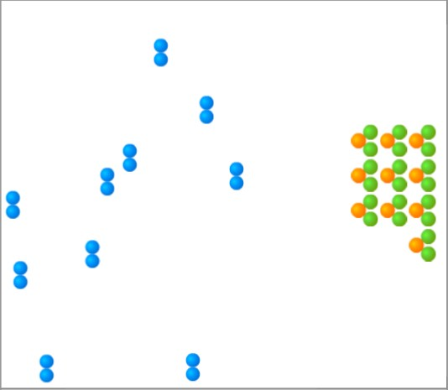
Introduction:
A chemical reaction causes the chemical compositions of substances to change. Reactants are substances that enter into a chemical reaction, and products are substances produced by the reaction. This simulation will allow you to experiment with several factors that affect the rate at which reactants are transformed into products in a chemical reaction.
You will need blue, green, and orange markers or colored pencils for the first part of this activity.
      - Look at the key at the bottom of the simulation pane. In the space below, draw the two reactants and two products of this chemical reaction.
Reactants: Products:
      - Click Play What do you see?
Activity A: Temperature | Get the Gizmo ready:  - Click Reset ).  - Check that the Reactant concentration is set to  1.0 mol/L, the Catalyst concentration is set to  0.00 mol/L, and the Surface area is Minimum. | 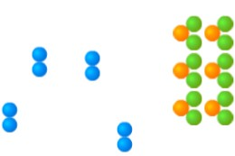
How does temperature affect the rate of a chemical reaction?
      - Observe: Select the ANIMATION tab. View the animation with No Catalyst selected. What do you see?
When two reactant molecules meet, they form a temporary structure called an activated complex. The activated complex breaks up into the product molecules.

      - Observe: Return to the CONTROLS pane. Set the temperature to 0 °C and the Simulation speed to its maximum setting. Click Play.
        - Describe the motions of the molecules.
        - Now set the Temperature to 200 °C. How does increasing the temperature affect the motions of the molecules?
        - What do you notice about the chemical reaction at the higher temperature?
      - Interpret: Sleect the GRAPH tab. Click the zoom out button (--) until you can see the whole graph. What does this graph show?
      - Predict: How do you think temperature will affect the rate of a chemical reaction?

Trial | 200 °C | 150 °C | 100 °C | 50 °C
1
2
Mean half-life
      - Gather Data: Click Reset. A useful way to compare reaction rates is to record the time required for half of the reactants to react, called the half-life of the reaction. With the Temperature set to 200 °C, click Play. Click Pause when the number of reactant molecules is 10. Record the half-life time in the first space of the table below.

Repeat the experiment at different temperatures to complete the table.
(Note: to get exact times, you can refer to the TABLE tab)

      - Calculate: Calculate the mean (average) half-life for each temperature. Fill in these values above.
(Hint: To get an exact mean, first convert each “minute” time to seconds, then add this to the seconds portion of the measurement. To find the mean in seconds, add up the two times and divide by two. Convert the answer back to minutes and seconds.)
      - Analyze: What do your results indicate?
      - Draw Conclusions: For two molecules to react, they must collide at just the right angle and with enough energy to break the original bonds and form new ones. Based on these facts, why does the reaction tend to go more quickly at higher temperatures?

Activity B:  Surface area and concentration | Get the Gizmo ready:  - Click Reset.  - Check that the Catalyst concentration is set to  0.00 mol/L and the Surface area is Minimum.  - Set the Temperature to 200 °C. | 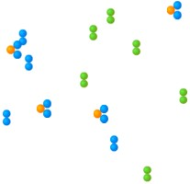
Introduction: Reaction rates are also influenced by surface area and concentration. The surface area of a solid is a measure of how much of the solid is exposed to other substances. The concentration of a substance is a measure of how many molecules of that substance are present in a given volume.

How do surface area and concentration affect reaction rates?

- Observe: Change the Surface area from Minimum to Maximum. How does this change the amount of Reactant B molecules that are exposed to Reactant A?

- Predict: How do you think increasing the surface area will affect the rate of the reaction?
- Gather data: Set the Reactant concentration to 2.0 mol/L. Use the Gizmo to measure the half-life of the reaction for each surface area setting. (There will now be 20 reactant molecules left at the half-life.) Then, calculate the mean half-life for each setting.

Trial | Minimum surface area | Maximum surface area
1
2
Mean half-life

- Analyze: What do your results indicate?

- Explain: Why does the reaction proceed more quickly when the surface area is increased?

- Observe: Click Reset. Move the reactant concentration slider back and forth. What do you notice?

- Predict: How will increasing the reactant concentration affect the rate of the reaction? Why?

- Gather data: Make sure the Temperature is 200 °C and the Surface area is Maximum. Use the Gizmo to measure the half-life for each given reactant concentration. (Note that the number of reactant molecules changes with each concentration.) Calculate the means.
Trial | 0.4 mol/L | 0.8 mol/L | 1.2 mol/L | 1.6 mol/L | 2.0 mol/L
1
2
Mean half-life

- Compare: If possible, find the mean times for each concentration for your entire class. What is the mean class time for a concentration of 0.4 mol/L? How about for 2.0 mol/L?

Mean for 0.4 mol/L: Mean for 2.0 mol/L:

- Analyze: What do these results indicate?
- Apply: Hydrochloric acid reacts with the mineral calcite to produce carbon dioxide gas, water, and calcium chloride. Based on what you have learned in activity A and activity B, what are three things you could do to make the reaction occur more quickly?
Activity C: Catalysts | Get the Gizmo ready:  - Click Reset ). | 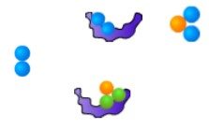
Introduction: A catalyst is a substance that helps a chemical reaction to proceed. The catalyst molecules are not changed by the reaction and can be reused over and over again.

How do catalysts affect the rate of a chemical reaction?

- Observe: Select the ANIMATION tab. Select With catalyst, and observe. What do you see?

Why do you think the shape of a catalyst is important?

- Predict: How do you think catalysts will affect the rate of a chemical reaction?

- Gather data: On the CONTROLS pane, set the Reactant concentration to 2.0 mol/L, the Surface area to Maximum, and the Temperature to 50 °C. Measure the half-life for each given catalyst concentration. Calculate the means.
Trial | Catalyst concentration
 | 0.00 mol/L | 0.05 mol/L | 0.10 mol/L | 0.15 mol/L
1
2
Mean half-life

- Analyze: What do your results indicate?
- Explore: Set the Catalyst concentration to 0.00 mol/L and the Temperature to 0 °C.
Click Play, wait for 10 minutes of simulated time, and click Pause.
What happens?
Click Reset, set the Catalyst concentration to 0.25 mol/L, and click Play. After 10 simulated minutes, click Pause.
What happens now?
Why do you think the catalysts allowed the chemical reaction to take place at 0 °C?

- Draw conclusions: What is the usefulness of catalysts?
- Apply: Most of the chemical reactions inside your body rely on protein catalysts called enzymes to take place. For example, the enzyme pepsin helps to break down protein molecules in your stomach. What might happen if your stomach stopped producing pepsin?

Notes on Potential Energy Diagrams Draw both diagrams for Endothermic and Exothermic reactions. Label every part of the graph and include definitions Potential Energy, Activation Energy, Activated Complex, Enthalpy (ΔH) and Transition State.

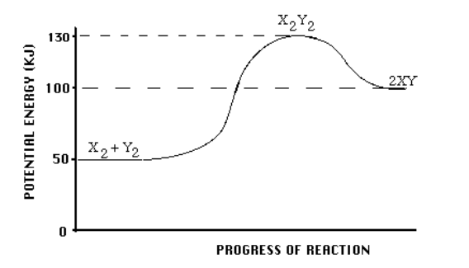
Use the Potential Energy Diagram below to answer the questions that follow.

      - Is the overall reaction as show endothermic or exothermic?
      - What is the activation energy for the forward reaction?
      - What is the activation energy for the reverse reaction?
      - What is the enthalpy change of the forward reaction?
      - What is the ΔH for the reverse reaction?
      - Is the reverse reaction endothermic or exothermic?
      - What is the chemical species of the activated complex?
      - What is the chemical species that has the highest potential energy?
      - What is the species that has the highest kinetic energy?
      - What do you think would be faster, the forward or reverse reaction? Why?
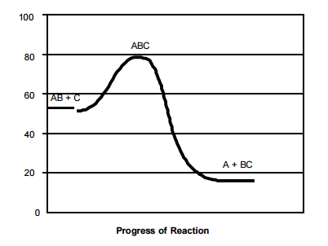
Use the Potential Energy Diagram below to answer the questions that follow.
Potential Energy (kJ/mol)

- What is the activation energy for the forward reaction?
- What is the activation energy for the reverse reaction?
- What is the ΔH of the forward reaction?
- What is the ΔH for the reverse reaction?
- Is the forward reaction endothermic or exothermic?
- Is the reverse reaction endothermic or exothermic?
- What is the chemical species of the activated complex?
- What species or set of species has the lowest potential energy?
- Which bon is stronger, A—B or B—C? Give reasons for your answer!
- What chemical species or set of species is moving the fastest? Give reasons for your answer!

Notes on Dynamic Equilibrium
Equilibrium
- Will a reaction occur? We use two things to determine this:
    - __________________________
    - __________________________
- How fast will the reaction be? We learned that reactions could be sorted into two categories:
    - __________________________
    - __________________________
FIVE factors that affect the rate of the reaction:
- __________________________
- __________________________
- __________________________
- __________________________
- __________________________
- How far will the reaction go?
  - ___________________________: The condition in which the _______ of the forward reaction equals the ________ of the reverse reaction.
      - When ________________________ is reached, the concentrations of the reactants and products no longer change.
      - This DOES NOT mean that the ______________ of reactant and products are equal.

LeChatlier’s Principle Overview:
- Definition of LeChatlier’s Principle
- LeChatlier’s Principle discusses things that will change the ____________ of reactions.
- Three types of things that will be of interest to us that affect the rates of reactions:
    - _________________________
    - _________________________
    - _________________________
Change in Concentration:
Example: H_{2 (g)} + Cl_{2 (g)} $⇌$ 2HCl _{(g)} ΔH = -184.60 kJ
- If we added more H₂ to the reaction, which direction would it shift towards?
- If we added more HCl to the reaction, which direction would it shift towards?
- If we remove Cl₂ from the reaction, which direction would it shift towards?
SOLIDS have __________________________________________________________________________

Change in Temperature:
Example: H_{2 (g)} + Cl_{2 (g)} $⇌$ 2HCl _{(g)} ΔH = -184.60 kJ
- Is the reaction endothermic or exothermic?
- If we put the reaction in ice water, which direction will it shift towards?
- If we put the reaction in hot water, which direction will it shift towards?
Change in Pressure:

- Pressure is special because it only affects ______________. If there is an ________ in pressure, the equilibrium will shift to the side of the reaction with _____________ moles of gas.

Example: N_{2 (g)} + 3H_{2 (g)} $⇌$ 2NH_{3 (g)} ΔH = -92.22 kJ
  - Which side has more moles of gas?
  - If we change the pressure from 1.00 atm to 0.25 atm, which direction will the reaction shift?
  - If we change the pressure from 0.70 atm to 1.50 atm, which direction will the reaction shift?

Student Exploration: Equilibrium and Concentration
Go to www.explorelearning.com and log in to your Gizmo account.
1st Block: FFVD9NNMTH 3rd Block: T9V7C5XRLH 4th Block: NDBZCBRFHT
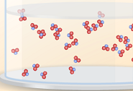
Gizmo Warm-up
Equilibrium occurs when two opposing processes occur at the same rate, leading to no net change. In the Equilibrium and Concentration Gizmo™, you will investigate how equilibrium can occur in chemical reactions.
To begin, check that Reaction 1 is selected. Set Moles NO₂ to 8 and Moles N₂O₄ to 0.
- Click Play () and observe the colliding molecules. Click Bar Chart in the upper right-hand corner. What do you notice?
- Click Reset (), and set Moles NO₂ to 0 and Moles N₂O₄ to 8. Click Play. Click Bar Chart

What do you notice now?

- When a reaction can proceed in either direction, it is a reversible reaction. Based on what you have observed, is the synthesis of NO₂ into N₂O₄ a reversible reaction? Explain.

Activity A:  Reversible reactions | Get the Gizmo ready:  - Click Reset. Reaction 1 should be selected.  - Set Moles NO₂ to 8 and Moles N₂O₄ to 0.  - Move the Sim. speed slider all the way to the right.
- Predict: Suppose you began with 8 moles of NO₂ in the chamber. What do you think will happen if you let the reaction go for a long time?

- Test: Click Play. Select the BAR CHART tab and check that Moles is selected. Observe the bar chart for about 30 seconds. As time goes by, what do you notice about the bars representing moles NO₂ and moles N₂O₄?

- Observe: Click Pause (). Select the GRAPH tab. Click the (–) zoom control on the horizontal axis until you can see the whole graph. What do you notice?

This situation, in which the overall amounts of reactants and products does not change significantly over time, is called a chemical equilibrium.

- Record: On the BAR CHART tab, turn on Show data values. How many moles of NO₂ and N₂O₄ are there right now? Moles NO₂ __________ Moles N₂O₄ __________
- Calculate: Suppose all the NO₂ molecules were synthesized into N₂O₄. Given the equation 2NO₂ ⇄ N₂O₄, how many moles of N₂O₄ would be produced? _______________
- Experiment: Click Reset (). On the INITIAL SETTINGS tab, set Moles NO₂ to 0 and Moles N₂O₄ to 4. Click Play. Click Pause when the bars of the bar chart stop moving very much.

- List the current amounts of each substance: Moles NO₂ ______ Moles N₂O₄ ______

- How do these results compare to starting with 8 moles of NO₂?

- Summarize: In each trial, you started with the same amounts of nitrogen and oxygen. In this situation, did the equilibrium amounts change depending on the direction of the reaction?

- Set up the Gizmo: Click Reset () and select the EXPERIMENT tab on the left. On the INITIAL SETTINGS tab on the right, select Reaction 2. Set Moles NO to 5, Moles NO₂ to 5, and Moles N₂O₃ to 0. What are the reactants and product of this reaction?

Reactants: __________ __________ Product: __________

(Note: In this reaction, some of the NO₂ reactants combine to form N₂O₄, as in reaction 1.)

- Observe: Recall that a blue flash appears every time two reactants combine to form a product. A red flash appears every time a product dissociates into reactants. Click Play.

- At first, do you notice more blue flashes or red flashes?

- What do you notice about the frequency of blue and red flashes as time goes by?

- Click Reset. This time, start the experiment with 0 moles of NO and NO₂ and 5 moles of N₂O₃. Click Play. What do you notice about the red and blue flashes now?

- Explain: Think about how the numbers of blue and red flashes reflect the rates of the forward (reactants products) and reverse (products reactants) reactions.

- What happens to the rate of the forward reaction as the reactants are consumed?

- What happens to the rate of the reverse reaction as the products are produced?

- Why do reversible reactions always result in chemical equilibria?

LeChatlier’s Principle Practice with Equilibrium
1) Sulfuryl chloride, SO₂Cl₂, is a highly reactive gaseous compound. When heated, it decomposes as follows
SO₂Cl₂ (g) ↔ SO₂ (g) + Cl₂ (g). This decomposition is endothermic. Explain how the concentrations of each compound will change if the following occurs.

A) There is an increase in chlorine gas: [SO₂Cl₂] [SO₂] [Cl₂]

B) The volume of the container increases: [SO₂Cl₂] [SO₂] [Cl₂]

C) The pressure of the container increases: [SO₂Cl₂] [SO₂] [Cl₂]

D) The reaction is heated and temperature increases: [SO₂Cl₂] [SO₂] [Cl₂]
2) For each situation, indicate how the given reactions will respond to the change in equilibrium:
I) N_{2(g)} + 3 H_{2(g)} ↔ 2 NH_{3(g)} II) N_{2(g)} +2 O_{2(g)} ↔ 2 NO_{2(g)} III) N₂O_{4(g)} ↔ 2 NO_{2(g)}
A) If the pressure increased, indicate which of the reactions would shift to the left?

B) If the concentration of NO₂ increased, which of the reactions would shift to the left?

3) Predict the shift in equilibrium when the following reactions decrease their temperatures:
A) H₂ + Cl₂ ↔ 2 HCl + Heat B) CO(g) + H₂O(g) ↔ CO₂(g) + H₂(g) ∆H = 37.2 kJ/mol
4) 2 HI(g) + Cl₂(g) ↔ 2 HCl(g) + I₂(g) + heat
Describe how equilibrium changes in response to each of these statements:
A) Increasing the volume of the container:
B) Decreasing the pressure inside the container:
C) Increasing the temperature at a constant volume:
D) Increasing the concentration of chlorine gas:

